OBJECT ORIENTED PROGRAMMING USING JAVA

NAME : T.R.DIVYASREE

DEPT & SEC : CSE & B

ROLL NO : 230701083

WEEK : 7

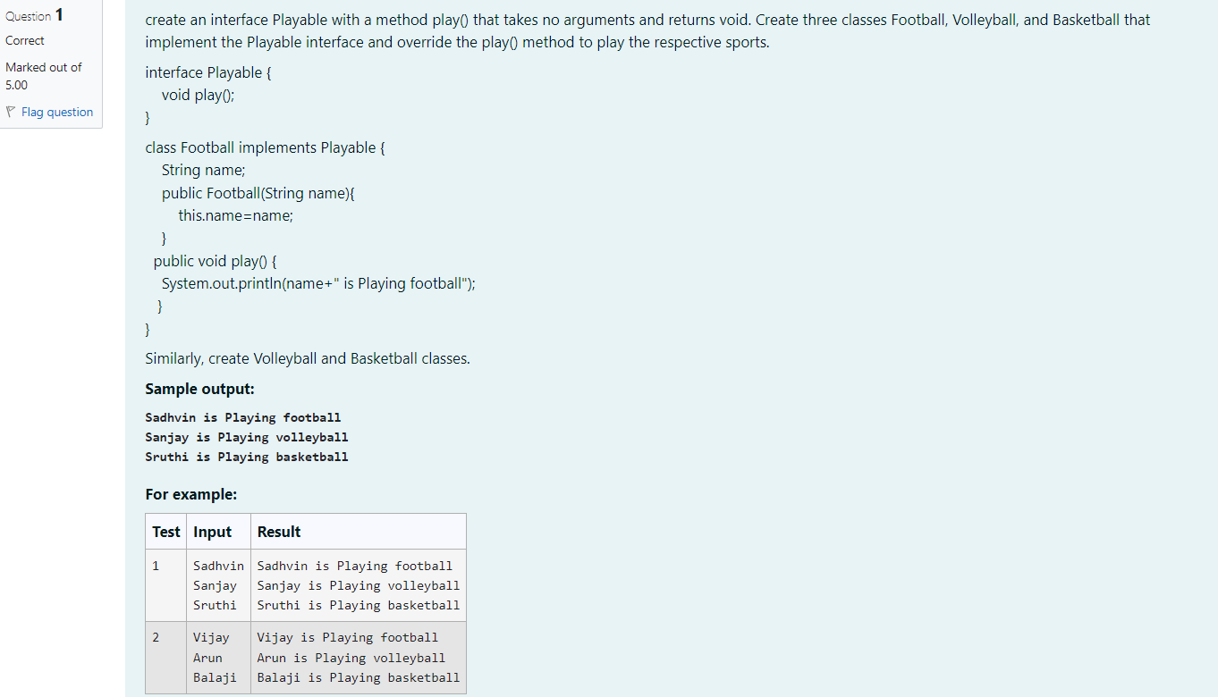

import java.util.Scanner;

interface Playable {

void play();

}

class Football implements Playable {

String name;

public Football(String name) {

this.name = name;

}

public void play() {

System.out.println(name + " is Playing football");

}

}

class Volleyball implements Playable {

String name;

public Volleyball(String name) {

this.name = name;

}

public void play() {

System.out.println(name + " is Playing volleyball");

}

}

class Basketball implements Playable {

String name;

public Basketball(String name) {

this.name = name;

}

public void play() {

System.out.println(name + " is Playing basketball");

}

}

public class Main {

public static void main(String[] args) {

Scanner scanner = new Scanner(System.in);

String footballPlayerName = scanner.nextLine();

String volleyballPlayerName = scanner.nextLine();

String basketballPlayerName = scanner.nextLine();

Football footballPlayer = new Football(footballPlayerName);

Volleyball volleyballPlayer = new Volleyball(volleyballPlayerName);

Basketball basketballPlayer = new Basketball(basketballPlayerName);

footballPlayer.play();

volleyballPlayer.play();

basketballPlayer.play();

scanner.close();

}

}

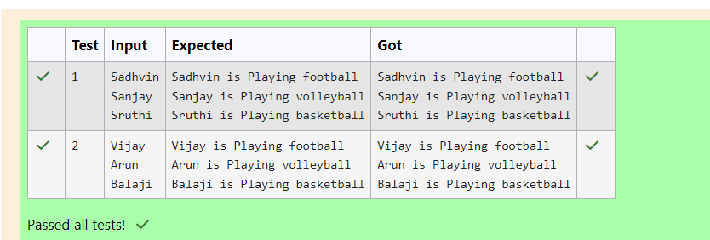

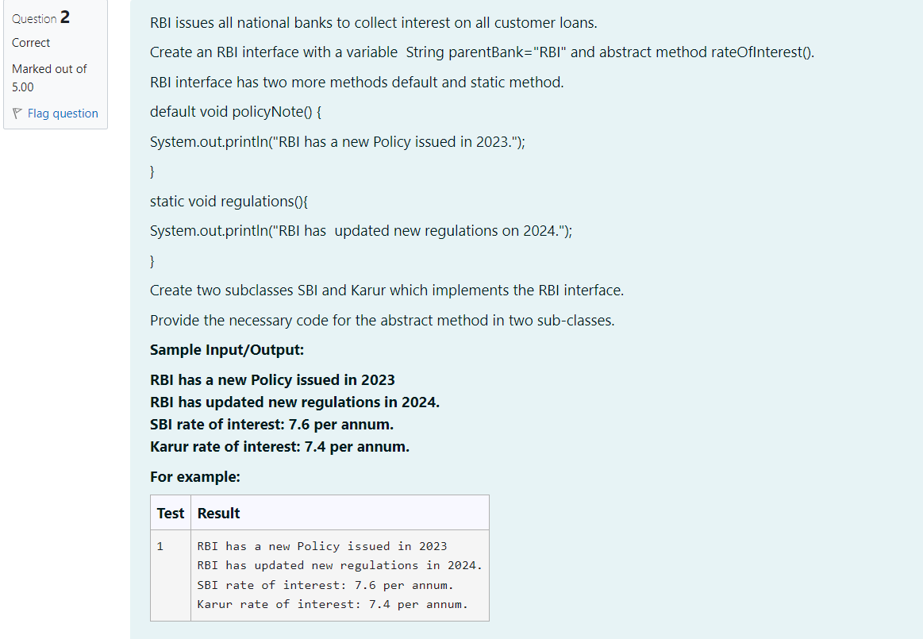

interface RBI{

String parentBank ="RBI";

double rateofInterest();

default void policyNote() {

System.out.println("RBI has updated new regulations in 2024.");}

static void regulations() {

System.out.println("RBI has a new Policy issued in 2023");}

}

class SBI implements RBI{

public double rateofInterest() {

return 7.6;

}

}

class Karur implements RBI {

public double rateofInterest() {

return 7.4;

}

}

public class Main {

public static void main(String[] args) {

RBI.regulations();

SBI sbiBank =new SBI();

Karur karurBank =new Karur();

sbiBank.policyNote();

System.out.println("SBI rate of interest: "+ sbiBank.rateofInterest()+" per annum.");

System.out.println("Karur rate of interest: "+karurBank.rateofInterest()+" per annum.");

}

}

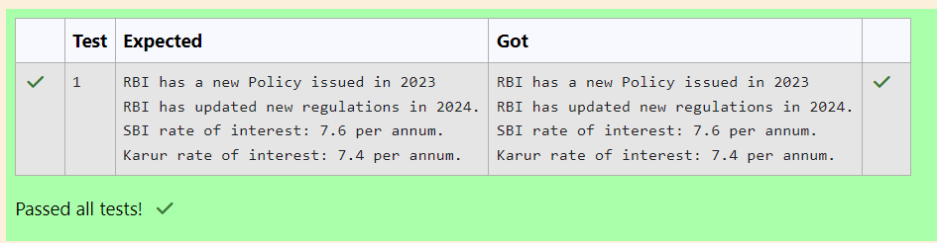

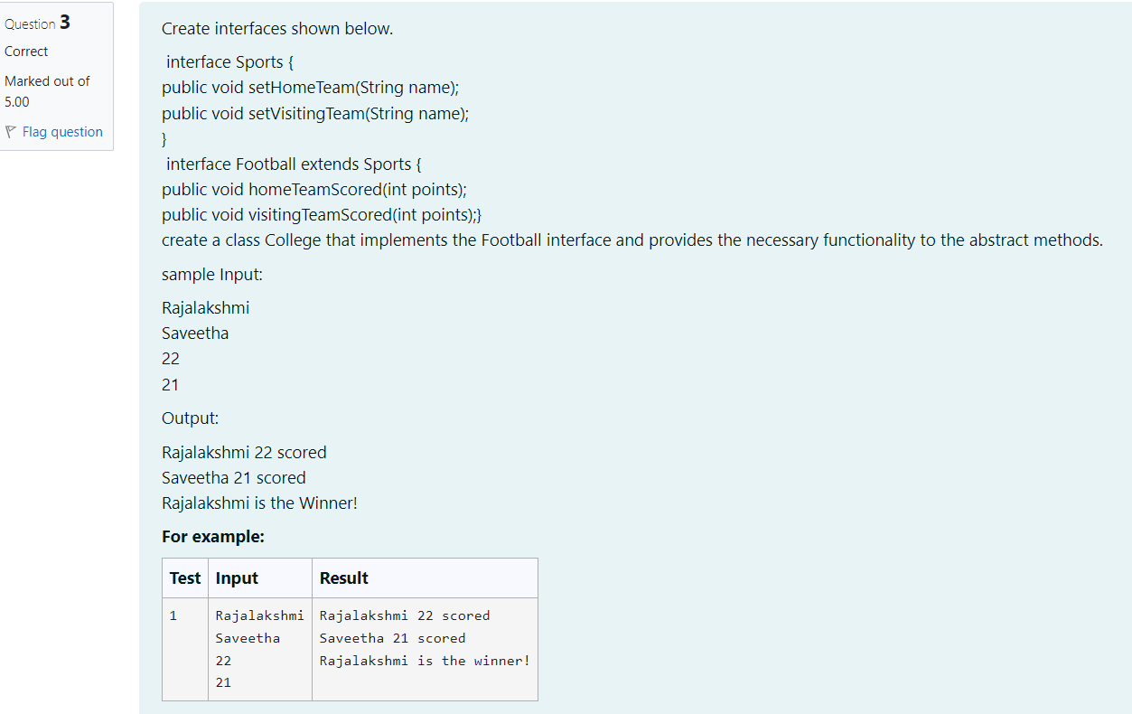

import java.util.Scanner;

// Sports Interface

interface Sports {

public void setHomeTeam(String name);

public void setVisitingTeam(String name);

}

// Football Interface extending Sports

interface Football extends Sports {

public void homeTeamScored(int points);

public void visitingTeamScored(int points);

}

// College class implementing Football interface

class College implements Football {

private String homeTeam;

private String visitingTeam;

private int homeTeamPoints;

private int visitingTeamPoints;

// Implementing setHomeTeam method

@Override

public void setHomeTeam(String name) {

this.homeTeam = name;

}

// Implementing setVisitingTeam method

@Override

public void setVisitingTeam(String name) {

this.visitingTeam = name;

}

// Implementing homeTeamScored method

@Override

public void homeTeamScored(int points) {

this.homeTeamPoints = points;

}

// Implementing visitingTeamScored method

@Override

public void visitingTeamScored(int points) {

this.visitingTeamPoints = points;

}

// Method to display the result

public void displayResult() {

System.out.println(homeTeam + " " + homeTeamPoints + " scored");

System.out.println(visitingTeam + " " + visitingTeamPoints + " scored");

if (homeTeamPoints > visitingTeamPoints) {

System.out.println(homeTeam + " is the winner!");

} else if (visitingTeamPoints > homeTeamPoints) {

System.out.println(visitingTeam + " is the winner!");

} else {

System.out.println("It's a tie match.");

}

}

}

// Main class to execute the program

public class Main {

public static void main(String[] args) {

Scanner scanner = new Scanner(System.in);

// Reading input dynamically

String homeTeam = scanner.nextLine(); // First input: Home team name

String visitingTeam = scanner.nextLine(); // Second input: Visiting team name

int homeTeamScore = scanner.nextInt(); // Third input: Home team score

int visitingTeamScore = scanner.nextInt(); // Fourth input: Visiting team score

// Creating an instance of College class

College collegeMatch = new College();

// Setting teams and scores

collegeMatch.setHomeTeam(homeTeam);

collegeMatch.setVisitingTeam(visitingTeam);

collegeMatch.homeTeamScored(homeTeamScore);

collegeMatch.visitingTeamScored(visitingTeamScore);

// Displaying the result

collegeMatch.displayResult();

}

}

